Bug Report For the Project:
X

 | General information
Customer | <Project name>
Created by (Author)
Preparation date
Version
Status

Revision History

Version | Description | Author | Date |  | Approved by
 |  |  |  | Author |  | Date

bug report example:

ID | Summary
R001 | [iOS] The "Address can not be empty" error is shown on the map screen after
 | selecting an address from google suggestions

# | Steps to reproduce
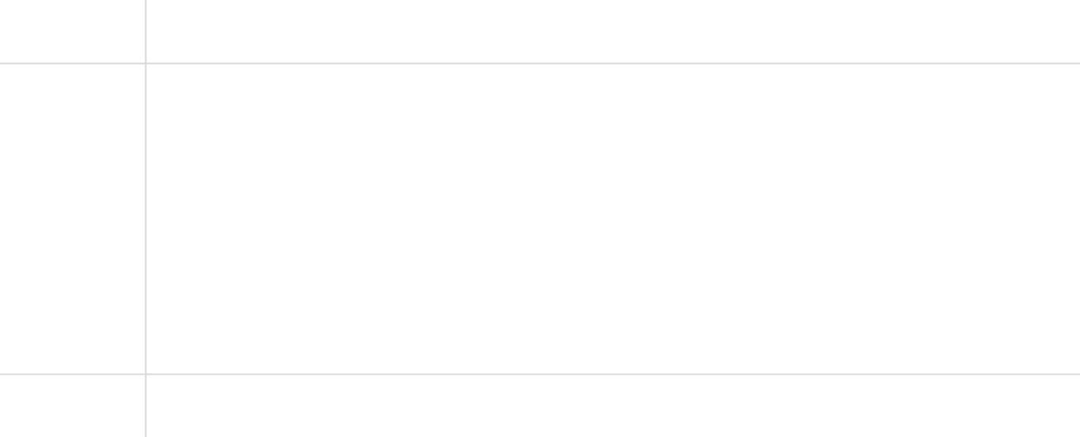

- Launch the app

2 | Sign up as a business owner
3 | Tap the "Address" drop-down on the "Profile information" screen
4 | Move the cursor to any street so google maps API will suggest the address
5 | Tap the suggestion
6 | Tap the green ">" button to submit

- Pay attention to the map screen

 | Results
Actual | The "Address can not be empty" error is shown on the map screen after
 | selecting an address from google suggestions
Expected | Google suggestion is saved as the address to the "Address" field of the "Profile
 | info" form after selecting an address from google suggestions
 | Additional information
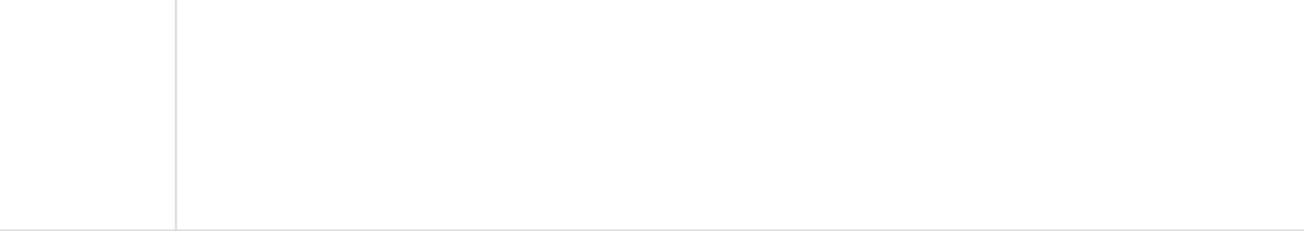

Video | https://screencast.com/t/example1
Build | 2.2.0_RC3
Devices | Samsung Galaxy S9 // Android 9.0
 | iPhone 8 // iOS 11.2.1

bug report:

ID | Summary

# | Steps to reproduce


2
3
4
5
6

Results
Actual
Expected
Additional information


Video
Build
Devices

